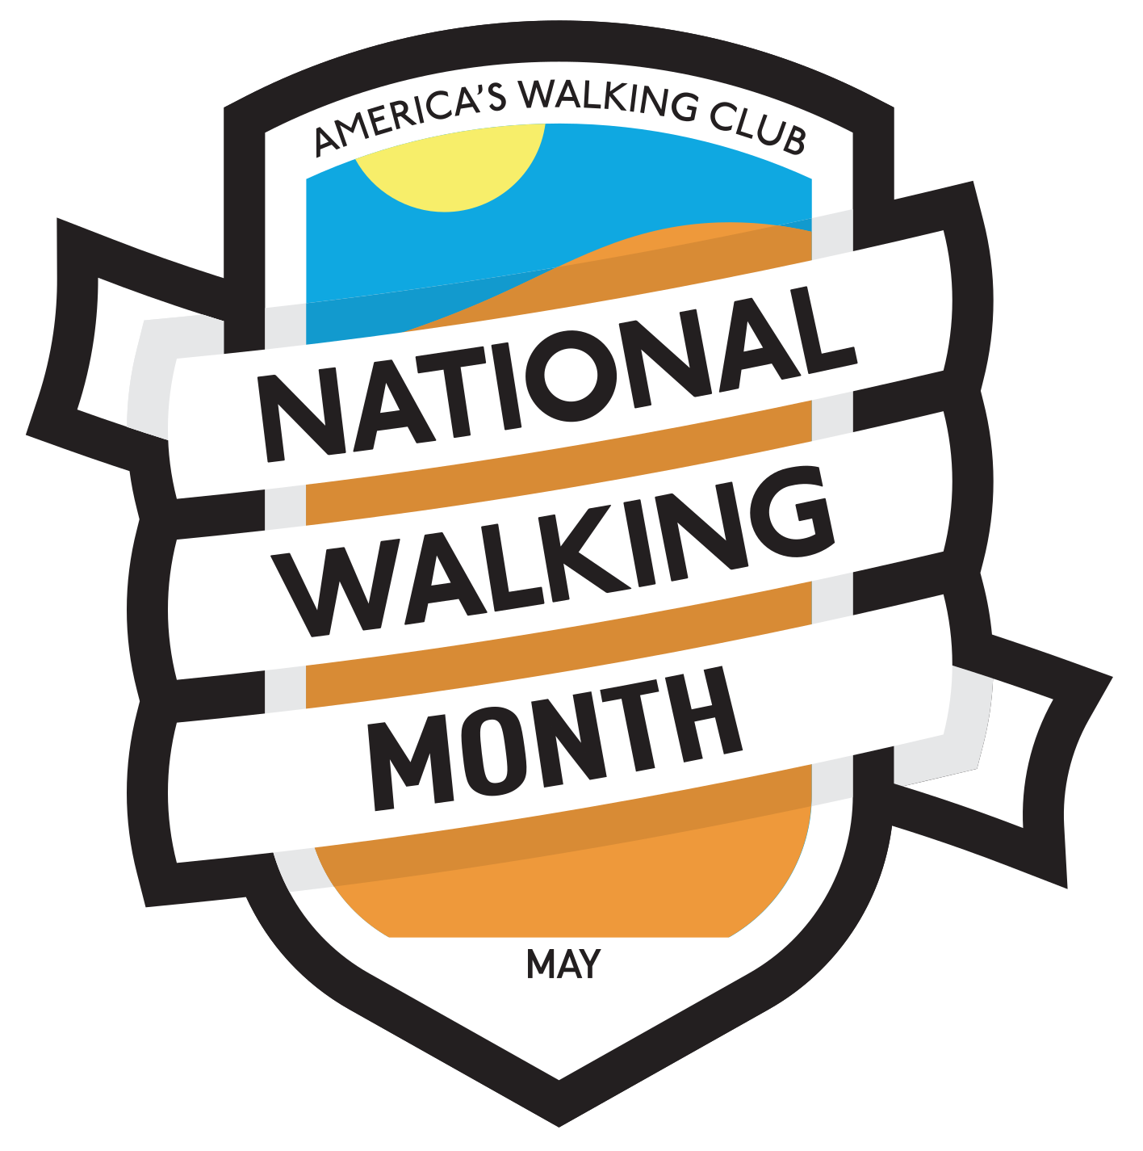
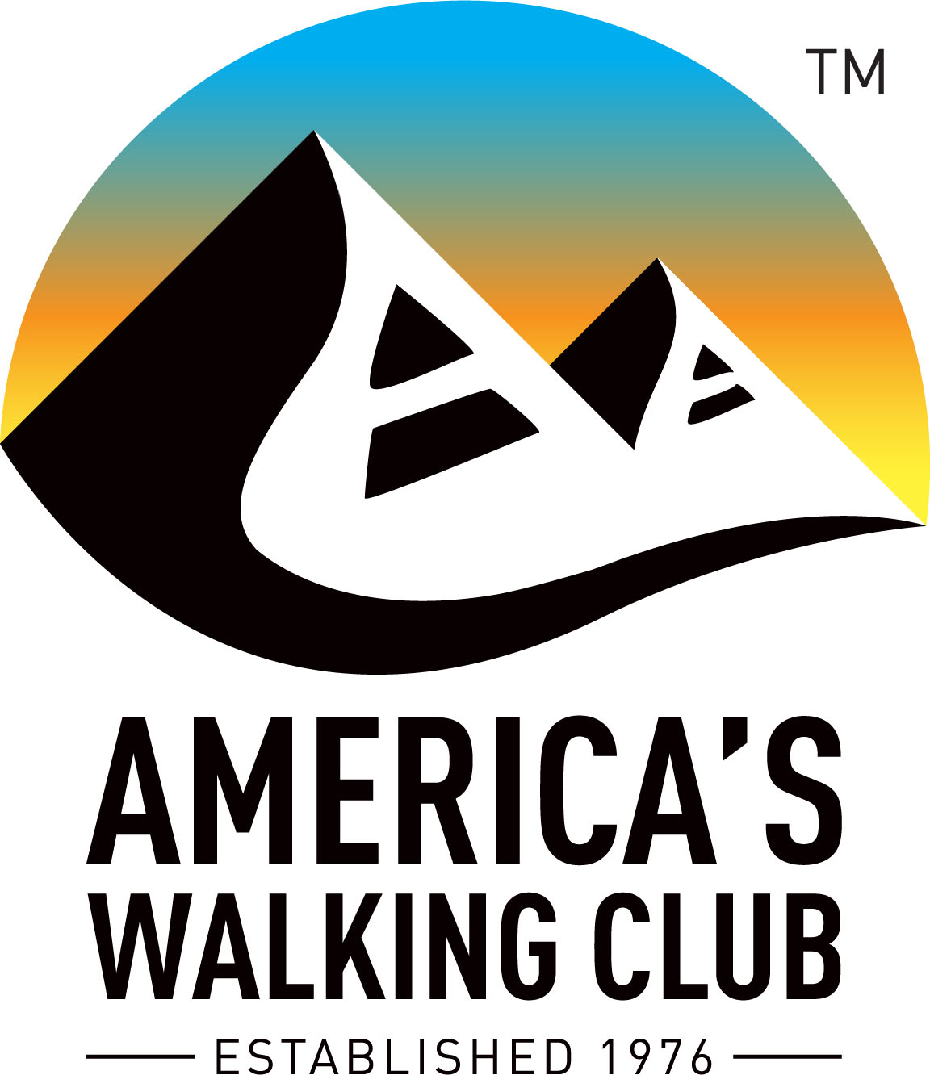

Contact: (Name)
(Phone Number and Email Address)

Join America’s Walking Club for National Walking Month in May
(Local Club Name and Location of Event(s))

Lace up your sneakers, grab your trekking poles, and prepare to enjoy a month of walking with America’s Walking Club during National Walking Month (dates of events and locations).

(Name of Local club) will host guided 10- and 5-kilometer walks starting at (Start time of Walks). Enjoy a non-competitive walk through (a brief description of the walk(s)).

Local residents are invited to join thousands of national walkers throughout the month in different communities across America. Come and walk at your own pace and experience the excitement of the walking movement through fun, fitness, and friendship.

To find a walk in your area go to www.ava.org and click on the National Walking Month icon. A detailed schedule of walks is available.

“This is a great opportunity to share the importance of walking with the nation and in our local communities,” said Nancy Wittenberg, chair of the American Volkssport Association.
The benefits of walking are numerous and proven. Walking is simple, effective exercise and does not require any training. A 2018 study published in the American Journal of Preventive Medicine found engaging in at least 150 minutes per week of brisk walking was linked to a 20% reduction in all causes of mortality.

###

AVA: America’s Walking Club America’s Walking Club – formerly known as the American Volkssport Association (AVA) is the largest walking club in the United States, A nonprofit organization founded in 1976, America’s Walking Club is dedicated to promoting personal physical fitness and good health by providing fun-filled, safe exercise in a stress-free environment through non-competitive walks and hikes, bike rides, swims, and in some regions cross-country skiing and snow shoeing. Its nationwide, grassroots network of almost 200 active clubs host more than 2,500 events annually across the country. Most of its walking events offer a pre-marked 10-kilometer trail with an option to walk 5 kilometers or less. Many people keep track of their walks with logbooks that they then receive awards for their distance and event achievements.

The national office of the organization is based in San Antonio, Texas. Visit ava.org for more information.
For more information visit www.ava.org or call 210-659-2112.

