Insert Club Logo

What is the “Walk Box?”

[Insert Club Name]
[Insert Address]

[Club Website]

There is large, grey plastic file box that your employer has agreed to keep here at the PORT ORANGE YMCA. It is normally located on the file cabinets behind the Information Desk and is labeled as “Happy Wanderers Walk Box.”

The box belongs to the Happy Wanderers – a (non-profit, 501c.) walking club based in Port Orange, FL. We are a member club of the American Volkssporting Association (AVA), promoting non-competitive fitness activities that are open to the public. We maintain several “year-round” walking routes that each has a Start Point like this one. Some are at hotels, libraries, state parks or even convenience stores.
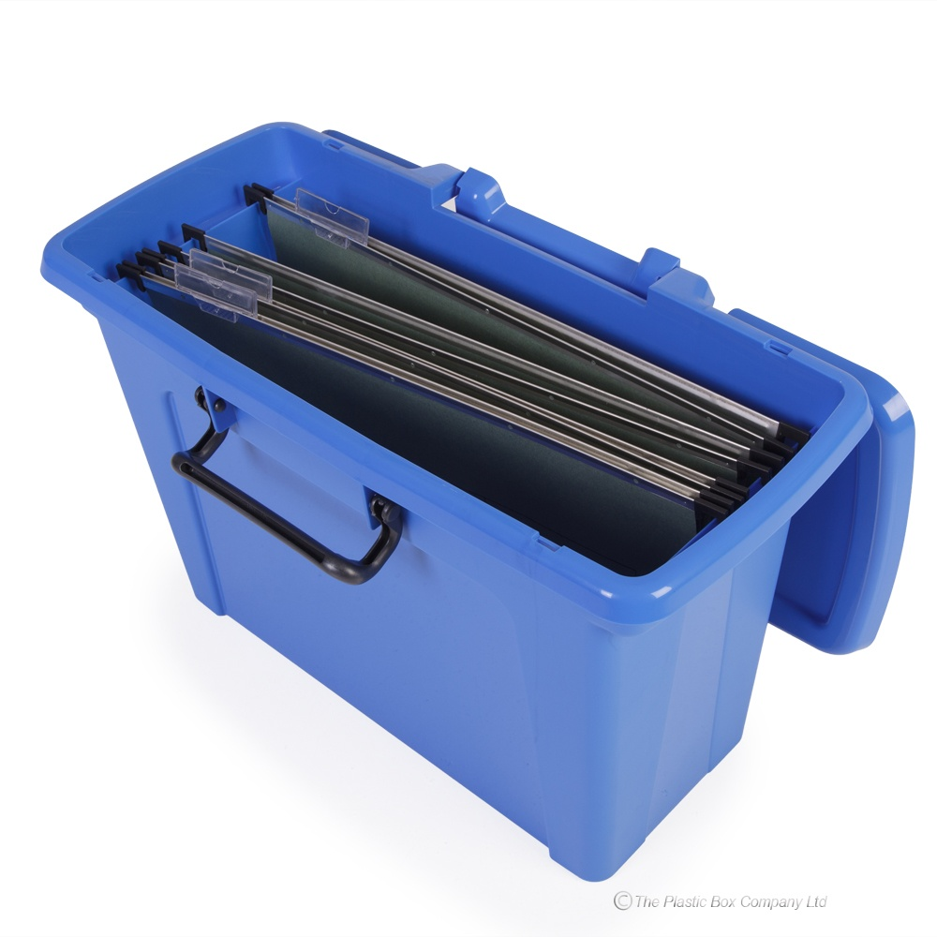
Our start points are part of a nationwide network of such events. These locations are listed online on the club and AVA websites. People will occasionally show up looking for “the walk box.” If someone comes in and asks for the Walk Box or the Volksmarching Box they have come here to register and complete the walk route that starts and finishes HERE.

What our Walkers will Do
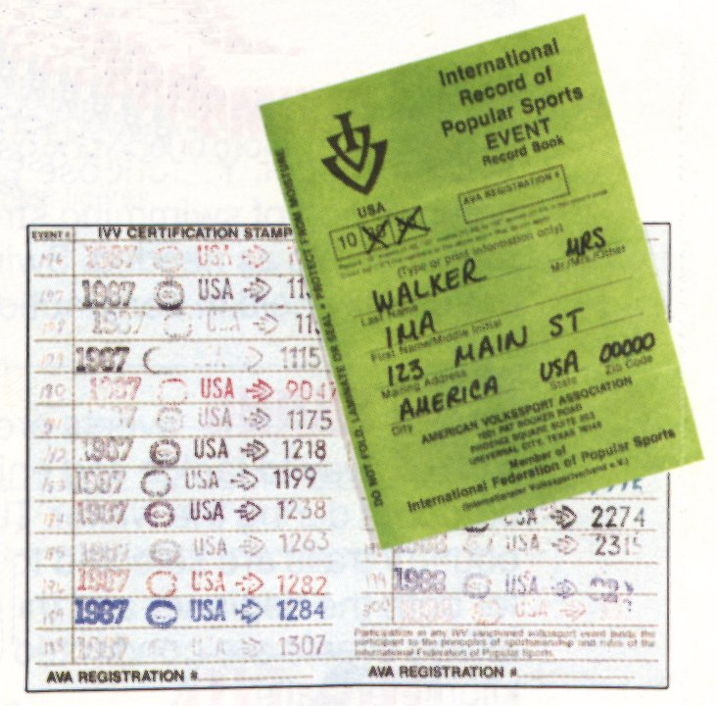
The walkers will need access to this box for few minutes – usually before starting the walk. The box contains a Registration Log to sign, maps of the route, self-addressed envelopes for the walkers to send their Start Cards and Registration Fee to us [NOTE: there is NO $cash money$ kept in this box] and a rubber Stamp – used by those walkers that participate in AVA Achievement awards for events and distance. The box may also contain additional information on the area, flyers about upcoming events and membership applications for our club.

Our process is conducted on an “honor system” so many walkers stamp their books before actually walking.

Once registered, our walkers will head out to begin their walk. They might or might not return afterwards. We do encourage our walkers to patronize your business!

The assigned Point-of-Contact (POC) in our club for this Walk Box is:

[POC Name], [Phone Number], [Email]

Please contact this POC if there are any issues with our box. You should see the assigned POC for this walk at least once every 3 months. The POC will maintain the materials in the box and make sure they are up-to-date. Once in a while, we may coordinate a group of walkers to all start together. If need be, we’ll let you know if we plan a Group Event of 25 or more participants.

Questions or Comments?
Contact the POC above; or [President or any other POC]

