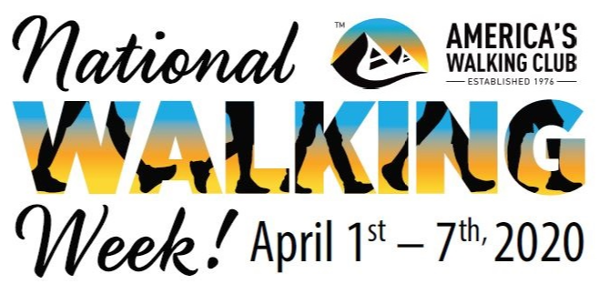

DECLARATION OF AVA: America’s Walking Club - National Walking Week
Whereas, the first Wednesday of April is declared and accepted as “National Walking Day” as first proclaimed by the American Heart Association in 2007; and,
Whereas, walking has benefits that exceed just the importance of health as first attributed to the day; and,
Whereas, walking is an important source of mental stimulation, growth and health through cultural and natural tourism, historical education, and providing connection to natural tranquility; and,
Whereas, walking as a recreational activity and a popular sport provides proven benefits to physical health for the heart, joints and movement, mitigating the impacts of aging, and in cancer prevention to name only a few; and,
Whereas, walking provides a sound and proven opportunity to experience the critical benefit of fellowship and companionship; and walking is crucial to human connections, community building and transportation infrastructures; and,
Whereas, walking provides the opportunity to experience spiritual connections to the world both seen and unseen; and,
Whereas, walking brings families together through the generations; and,
Whereas, walking, as a lifetime goal requires the opportunity for all people from all communities to experience the importance of walking in a variety of situations that exceed the capabilities of just one day in the middle of a week; and,
Whereas, the AVA: America’s Walking Club, the largest walking organization in the United States of America with affiliate clubs and members in all 50 states and at locations around the world with connections to allied organizations in over 40 different countries, has provided opportunities for walking to all since 1976 for fitness, fun and fellowship;
We, (name of organization making the declaration) do call upon all like-minded organizations for health and wellness, government, sport, education and tourism to join with us to declare the first seven (7) days of April in the United States of America, to include the first Wednesday of the month as “National Walking Day”, from this day until perpetuity as:

National Walking Week.
As declared on this day, the_(date)__th of (Month) 2020.

______________________________ _____________________________
(Name and Title) (Name and Title)

