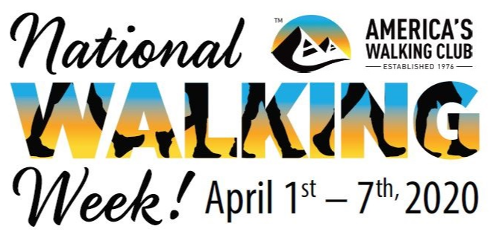

Contact: (Name)
(Phone Number and Email Address)

Join AVA: America’s Walking Club for National Walking Week!
(Local Club Name and Location of Event(s))

Lace up your sneakers, grab your trekking poles, and prepare to enjoy a week of walking with AVA: America’s Walking Club during National Walking Week on (Dates of events and locations).

(Name of Local club) will host guided 10- and 5-kilometer walks starting at (Start time of Walks). Enjoy a non-competitive walk through ( a brief description of the walk(s)).

Local residents are invited to join thousands of national walkers throughout the week in different communities across America. Come and walk at your own pace and experience the excitement of the walking movement through fun, fitness and friendship.

To find a walk in your area go to www.ava.org and click on the National Walking Day icon. A detailed schedule of walks is available here.

“This is a great opportunity to share the importance of walking with the nation and in our local communities,” said AVA President David Bonewitz.

The benefits of walking are numerous and proven. Walking is simple, effective exercise and does not require any training. A 2018 study published in the American Journal of Preventative Medicine, found engaging in at least 150 minutes per week of brisk walking was linked to a 20 percent reduction in all-cause mortality.

For a complete schedule of walking events in your area, visit: www.ava.org.

###

ABOUT AVA: America’s Walking Club
AVA: America’s Walking Club is the largest walking club in the United States. It is a national nonprofit organization with a mission to promote health and wellness through noncompetitive sporting events. The term “volkssport” is German for “sport of the people”. Volkssporting in the United States is sponsored by the American Volkssport Association (AVA), which has a nationwide, grassroots network of over 200 active clubs presenting more than 2,500 volkssporting events each year. People of any background, age, and ability are welcome to participate in the AVA’s noncompetitive sporting events. Participants set their own pace at any AVA events whether it be walking, biking, swimming, canoeing, cross-country skiing, or snowshoeing. No membership is required, only the motivation to walk! The AVA is a member of the International Federation of Popular Sports (IVV) and the International Marching League (IML). For more information visit www.ava.org or call 210-659-2112.

