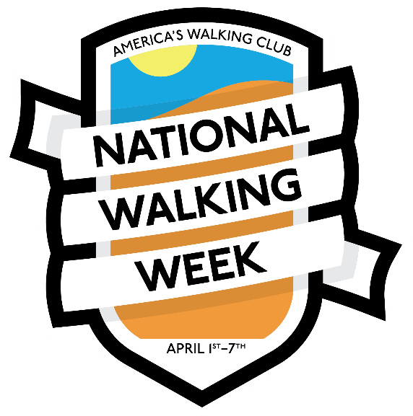
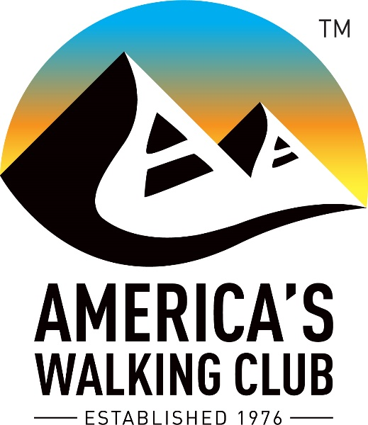

Contact: (Name)
(Phone Number and Email Address)

Join America’s Walking Club for National Walking Week
(Local Club Name and Location of Event(s))

Lace up your sneakers, grab your trekking poles, and prepare to enjoy a week of walking with America’s Walking Club during National Walking Week on (Dates of events and locations).

(Name of Local club) will host guided 10- and 5-kilometer walks starting at (Start time of Walks). Enjoy a non-competitive walk through (a brief description of the walk(s)).

Local residents are invited to join thousands of national walkers throughout the week in different communities across America. Come and walk at your own pace and experience the excitement of the walking movement through fun, fitness, and friendship.

To find a walk in your area go to www.ava.org and click on the National Walking Day icon. A detailed schedule of walks is available.

“This is a great opportunity to share the importance of walking with the nation and in our local communities,” said Nancy Wittenberg, chair of the American Volkssport Association.
The benefits of walking are numerous and proven. Walking is simple, effective exercise and does not require any training. A 2018 study published in the American Journal of Preventive Medicine found engaging in at least 150 minutes per week of brisk walking was linked to a 20% reduction in all causes of mortality.

###

AVA: America’s Walking Club is the largest walking club in the United States. It is a national nonprofit organization with a mission to promote health and wellness through noncompetitive sporting events. We have a nationwide, grassroots network of more than 200 active clubs presenting more than 2,500 events each year. The club is a member of the International Federation of Popular Sports (IVV) and the International Marching League (IML). For more information visit www.ava.org or call 210-659-2112.

